TO DO!

* Setup Brand new unity file. Get it from the university with the newest version you can. See how you can get the newest version.
* Prototype some ideas!
* Point and click cursor. When it comes to controls standard RTS control.
* Done notes on the concept jpegs.
* Will need a way to hold the spawning locations of flooring.
  + For spawning this stuff will need to know how unity’s spawning system works
  + Going to need to sync this with a tile map so it snaps to it properly.
    - Need to create a script to create new flooring on the fly.
    - Hold all those objects within an array (Which is not too hard it seems)
    - <https://gamedev.stackexchange.com/questions/197288/how-to-spawn-gameobjects-at-random-positions-in-unity> Seems to be a decent answer.
    - <https://medium.com/swlh/is-using-linq-in-c-bad-for-performance-318a1e71a732>
    - <https://stackoverflow.com/questions/871230/how-do-i-use-linq-in-monodevelop-2-0-on-os-x/875704#875704>
  + Will need to operate on a grid when placing rooms.
    - <https://www.mikoweb.eu/fallout-shelterish/>
    - <https://www.youtube.com/watch?v=rKp9fWvmIww&t=0s&ab_channel=TamaraMakesGames>
    - <https://www.youtube.com/watch?v=gFpmJtO0NT4&ab_channel=TamaraMakesGames>
    - <https://www.youtube.com/watch?v=HbKbxN6Oo6I&t=0s&ab_channel=TamaraMakesGames>
    - Perhaps tile maps is the way to go about it.
    - https://gamedev.stackexchange.com/questions/33140/how-can-i-snap-a-game-objects-position-to-a-grid
    - <https://gamedev.stackexchange.com/questions/174603/how-to-handle-grid-snapping-when-the-object-is-greater-than-the-grid-cell-width>
    - This seems to me the best way to do it right now
    - Test with cube first
      * Need to find a way to show grid
      * <https://www.youtube.com/watch?v=waEsGu--9P8&ab_channel=CodeMonkey>
      * https://www.youtube.com/playlist?list=PLzDRvYVwl53uhO8yhqxcyjDImRjO9W722
      * Will need to change how the grid code takes stuff in to use generic types so we can have each grid hold an object type instead.
      * Make sure you understand this as you will have to remake it later.
  + Keep the scale of the project in mind when making objects and such.
* Will need to find a way to keep track of how much energy has been used and then translate that into something that has real world connotations.
  + Large scale backend AI
  + Look at how stuff like fnaf and plague inc managed this.
  + Will need to know more about the production process.
* Will need interactable UI for the dashboard.
  + Look into how deep the UI for unity goes and the best ways to go about it.
  + Maybe look into physically interactable UI like pulling a lever.
    - <https://gamedevbeginner.com/how-to-move-an-object-with-the-mouse-in-unity-in-2d/>
    - <https://stackoverflow.com/questions/25912965/how-to-limit-the-rotation-of-a-game-object-in-unity3d>
    - Let S be the distance covered in n complete rotations and d be the diameter of the wheel. For one rotation the distance covered is πd
    - So S= distance covered in n rotations = πdn
    - So the number of rotations n = S/πd
    - 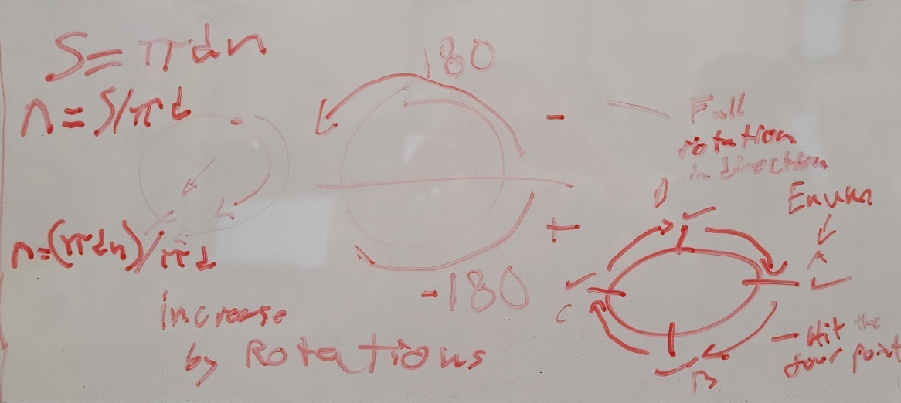Have Enums for each cardinal direction point and depending on if we hit them in an order we increase the value.

Rotation count logic

* + - https://forum.unity.com/threads/solved-how-to-get-rotation-value-that-is-in-the-inspector.460310/

Tasks to do for this:

Fallout shelter management room placement stuff

1. Spawn random rooms
2. Place rooms according to mouse click.
3. Snap rooms to grid.
   1. Snapping cubes to grid
   2. Snapping longer odd-shaped(Rectangles) pieces to grid
   3. Have rooms be able to connect horizontally but different layers need to be reached with other pieces that will be elevators.

Dashboard User Interface

1. General menu system
   1. Buttons and switches
      1. Buttons
         1. Clicked does something.
      2. Switches
         1. ON or OFF Boolean
2. Pullable levers and rotatable dials
   1. Movable sprite with mouse
   2. Rotate object with mouse drag.
   3. Need to be able to measure that it is being moved(increase power based off spin)
   4. Fixed point at one end
   5. Lock the pivot to be between a certain angle.
3. Pullies and sliders
   1. Sliders
      1. Lock an objects x and z but have it move in the y.
   2. Pullies
      1. Same logic as slider except the location gets reset.
4. Need to have the levers and sliders activate at certain max heights and angles.
5. Diagram

   Description automatically generatedNeed to show where the mouse was originally when it was clicked(Can be used for touch aswell) as demonstrated in the diagram below.
   1. Draw a line from the old mouse position to the new mouse position.
   2. Only draw the line when the mouse is attached to an object.
   3. Stick the drawn from point to the held object.
      1. Maybe I need to use it like a grappling hook between the object and the mouse object.
      2. Need to give it an offset relative to the objects position.
6. Need for these objects to be moved by the mouse but for them to have certain amount of movement they can do as with the wheel for example it could go way faster round depending on the mouse at the moment. Need to give it some friction.
7. Sliders that click up between different options as you move them up.

Backend AI to manage how the energy and materials work.

1. Needs to manage all the backend stuff like production statistics like energy usage.(Got a pseudocode diagram file for that)